Project Design Phase-II
Data Flow Diagram & User Stories

Date | 31 January 2025
Team ID | LTVIP2025TMID36086
Project Name | Enchanted Wings: Marvels of Butterfly Species
Maximum Marks | 4 Marks

🦋 Enchanted Wings: Marvels of Butterfly Species
covering both Data Flow Diagram (DFD) and User Stories in the required format.

✅ Data Flow Diagram (DFD) – Level 0 (Context Level)

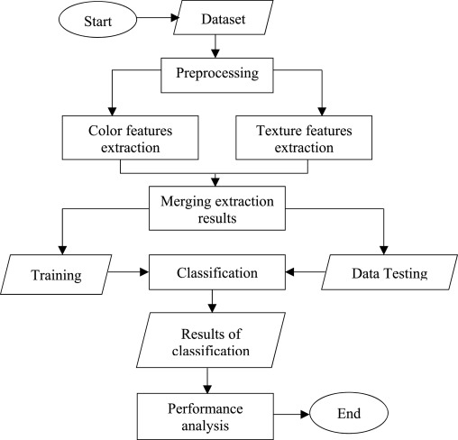

+------------------+ +--------------------+
| | Upload | |
| User | ---------> | Web Interface / |
| (Field Researcher| Image | Streamlit Frontend|
| or Student) | | |
+------------------+ +--------------------+
|
v
+----------------------+
| Preprocessing Unit |
| (Resize, Normalize) |
+----------------------+
|
v
+--------------------------+
| VGG16 Classifier Model |
| (Predict Butterfly Class)|
+--------------------------+
|
v
+-----------------------------+
| Result Display + Confidence |
| Species Info + Suggestions |
+-----------------------------+

📝 User Stories Template
User Type | Functional Requirement (Epic) | User Story Number | User Story / Task | Acceptance Criteria | Priority | Release
Researcher / Student | Image Upload | USN-1 | As a user, I can upload an image of a butterfly to the app | I can view the uploaded image preview | High | Sprint-1
Researcher / Student | Classification Output | USN-2 | As a user, I can get the predicted butterfly species from the system | I see the predicted species name with a confidence score | High | Sprint-1
Researcher / Student | Visualization | USN-3 | As a user, I can see a pie chart of class distribution | I view a pie chart showing species distribution in training data | Medium | Sprint-2
Researcher / Student | Educational Info | USN-4 | As a user, I can learn about the predicted species | I see a short description of the butterfly species | Medium | Sprint-2
Public Contributor | Feedback Collection | USN-5 | As a user, I can provide feedback on wrong predictions | I can submit comments for model improvement | Low | Sprint-3
Administrator | Dataset Management | USN-6 | As an admin, I can upload new training images and relabel classes | I see updated image counts per class | High | Sprint-3
Administrator | Model Retraining Trigger | USN-7 | As an admin, I can trigger a model retraining process | A retraining log is generated post-training | Medium | Sprint-4
Web User | Dashboard Access | USN-8 | As a user, I can interact with the model through a web-based dashboard | Dashboard loads with upload and prediction functionality | High | Sprint-1

